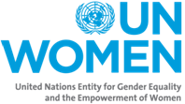
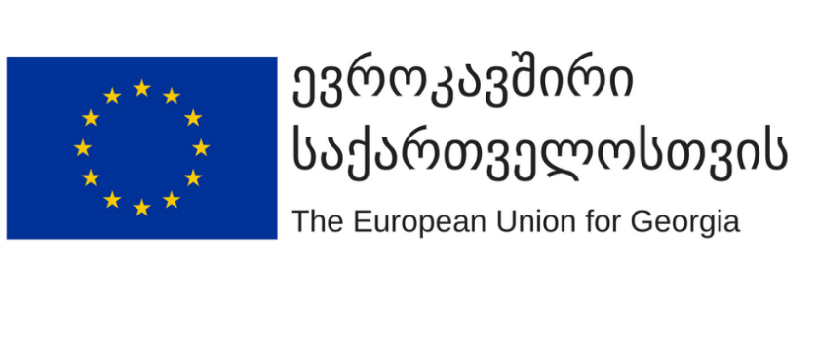

LETTER OF AGREEMENT EU ADDENDUM

Project: Unite to Fight Violence against Women (EUD)
Project Reference: 00098242 -EVAWG_Enabling Environment

Addendum to the Letter of Agreement between The State Fund for the Protection and Assistance to the (Statutory) Victims of Human Trafficking and UN-Women in relation to the Unite to Fight Violence against Women

The Letter of Agreement is subject to the following:

Further reference is made to the European Union PA Grant Agreement ENI/2016/358-891 between UN Women and the European Union represented by the European Commission on 13/09/2016 (Annex 1), where the European Commission allocated funds to UN Women for the Project.

"The Agreement" or "the present Agreement" shall mean the present Letter of Agreement (the Letter), the European Union PA Grant Agreement ENI/2016/358-891 as applicable, the Project Document (Annex 2], which incorporates the Project Objectives and Activities, Project Work Plan, Project Inputs being provided by UN WOMEN resources, and Project Budget, and all other documents agreed upon between the Parties to be integral parts of the present Agreement. The documents comprising this Agreement are complementary of one another, but in case of ambiguities, discrepancies, or inconsistencies between the Letter and the European Union PA Grant Agreement ENI/2016/358-891, the following order of priority shall apply:
1. First, the European Union PA Grant Agreement ENI/2016/358-891 Agreement as applicable;
2. Second, the Letter.

In accordance with Articles 1.1 and 1.2 of Annex II.b – Provisions applicable only to calls for proposals and other specific circumstances, Articles 5 (Conflict of interests), 8 (Communication and Visibility), 16 (Accounts and archiving) and Article 17 (Access and financial checks) of Annex II - General Conditions for PA Grant or Delegation Agreements apply mutatis mutandis to the State Fund for the Protection and Assistance to the (Statutory) Victims of Human Trafficking.

The State Fund for the Protection and Assistance to the (Statutory) Victims of Human Trafficking shall have full programmatic and financial accountability for the use of the Project funds and for the results of the Project activities. In this regard, in addition to and notwithstanding the terms of the LOA, the Government Institution agrees to implement and comply, and ensure compliance, with all European Union PA Grant Agreement ENI/2016/358-891 Agreement provisions and requirements imposed on the Government Institution mutatis mutandis. All reporting required of the Government Institution under the LOA shall be provided by the Government Institution to UN Women in adequate time in order for UN Women to review and consolidate that reporting for overall reporting to the EU under European Union PA Grant Agreement ENI/2016/358-891.

In the event that the EU considers ineligible any expenses incurred, payments made or activities undertaken with respect to the Project activities implemented by the Government Institution under the LOA, further to the Activities financed under the European Union PA Grant Agreement ENI/2016/358-891, the Government Institution assumes full financial responsibility for these expenses, payments or activities, and the consequences thereof, in accordance with the terms of the European Union PA Grant Agreement ENI/2016/358-891. Such expenses, payments or activities shall be deemed in breach of Paragraph 11 of the LOA and unapproved by UN Women. Further to Paragraph 11 of the LOA, UN Women shall not be liable any such expenses, payments or activities. The Government Institution shall seek to resolve the issue directly with the EU. If the EU refuses or the matter is otherwise not able to be resolved, the Government Institution will hold UN Women harmless and indemnify it against all claims and demands made by the EU, and any related expenses incurred by UN Women in defending against any such claim or demand.

